Game of Thrones sentiment analysis

**Name: Jeppe Strelow Lund AND Alberte Holm Ravn**

**Date: 21/03-2025**

**URL to Github code** Game of Thrones Text mining, sentiment analysis, and visualization

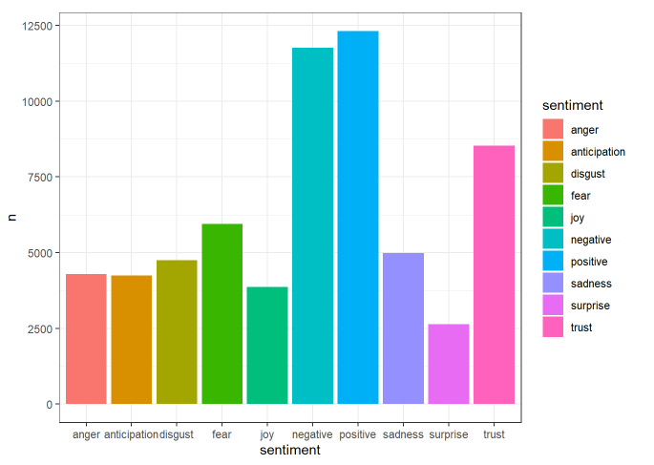**Visualisation:** (*include a legible and meaningful graphic with clear labels and no scientific notation*)

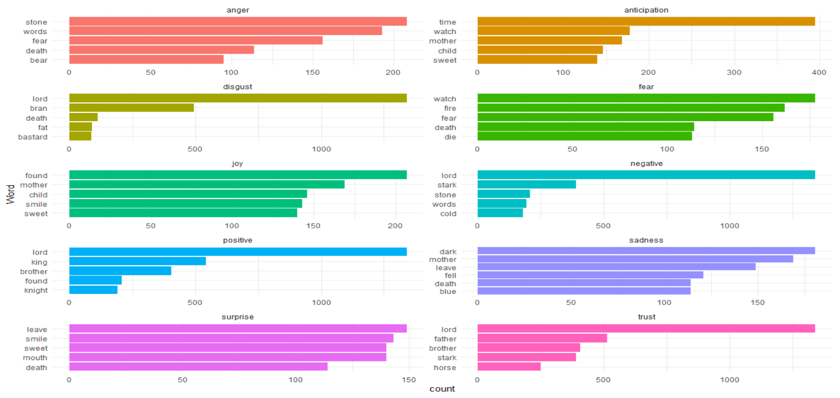

**Significance**:  *Explain in 250 words what your visualisation (sentiment chart, map, or colonial legacy timeseries or regression chart) represents and what are its implications vis-a-vis your [historical]  research question? Also, consider briefly what your visual does not show.*

The problem with analyzing Game of Thrones and looking at it from a sentimental analysis perspective is that it doesn’t surprise anyone who already knows the story. Game of Thrones is a well known cultural impactful series, so the fact that the Sentiment analysis of *Game of Thrones* reveals that the dominant words in the series are heavily weighted toward negative emotions, reflecting the grim and tumultuous nature of the story. The predisposed knowledge just confirms what we already know. With that being said, we can also see that the story isn’t without positive sentiments which we can presume is being used as a sort of levity between the harsh scenes that we know is in Game of Thrones.

However, what the visualizations do not show is the nuance and depth behind these data points. A sentiment chart may overlook the broader context or subtext behind specific moments in *Game of Thrones*, such as character development or social-political commentary embedded in the storyline. Similarly, a colonial legacy timeseries might not capture the human experience behind the numbers, such as the emotional and psychological impact on individuals or communities.

In summary, while visualization offers valuable insight into the overarching trends and patterns, it does not fully encapsulate the complexities and underlying causes of the phenomena being studied.